Join me in celebrating the publication of my Memoir.

10% of the proceeds from sales of the book will be donated to the Breast Cancer Research Foundation.

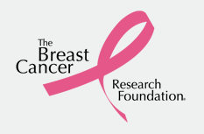
www.bcrfcure.org
Get your autographed copy today of my Spiritual Memoir! $16.95 with cash, check or credit cards accepted. Find me at Amazon.com in print and Kindle or at Barnes and Noble, Nook®, or at www.susanstockton.com

